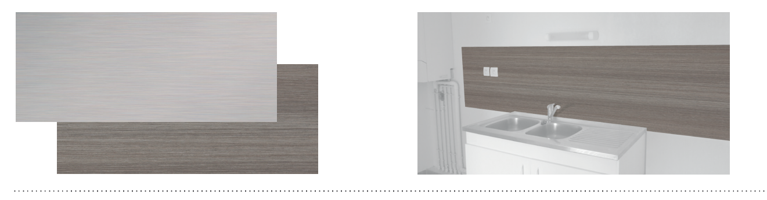


SPECIFICATION

DECOTREND H₂O / DECOWOOD H₂O
DECORATIVE PROTECTION AND COVERING PANEL – 2 MM
FOR WET AREAS

- Description: 2 mm thick protection and covering panel for wet areas (Decotrend H₂O or Decowood H₂O as manufactured by SPM) from rigid and wood or trend decor PVC achieving Bs2d0 fire rating. The surface finish is metalized or concrete, or wood. 2.50 m long, 1.30 m high.
- To ensure watertightness of the system, the panels are thermo-welded to each other and to the PVC skirting by means of a welding rod (H₂O welding rod as manufactured by SPM). Any connections with other materials are made with a silicone joint (H₂O silicone joint as manufactured by SPM). The chemical and mark resistance of the panel should have been proven on the usual cleaning products according to ISO26987.
- Environment: no heavy metals and no substance potentially subjected to any REACH restriction are used in its manufacture, nor PBT/BPA. The calcium-zinc thermal stabilization process is used. The emission level of volatile substance in inside air has been tested according to ISO16000-6 and is very low (A+) according to the French regulation (23 March 2011 nr 2011-321 Decree and 19April 2011 Order). 100% of the product are recyclable.
- Colours: selected by architects from manufacturer’s standard range.
- Installation method: glue as per manufacturer’s instructions. The installer must have been trained beforehand by the manufacturer to install this system.
